# Gameplay

## Summary

“Micro Mayhem” puts the player in control of a technologically advanced form of medication, wittingly name “RoboPill”. RoboPill is a new form of medication that was able to be developed due to recent medical advancements. The player’s job, as RoboPill, is to enter the patients system, and destroy all harmful bacteria whilst saving as many healthy cells as possible. The player will progress through the game in a level-based fashion, earning evolution points at the end of each level depending on how well he was able to help the patient.

## RoboPill

RoboPill is the result of thousands of hours of medical research and micro-bacterial evolution. With the intended result being an extremely potent and multi-purpose medical capsule, RoboPill is able to enter a subject’s system and combat 90% of the world’s most fatal diseases.

RoboPill’s body is divided into two parts; the upper body, and the lower body. The lower body is made up of a rotational thruster, allowing for a full range of motion throughout a subject’s system. The upper part is a more combat ready segment, which can rotate around its centre in a 360 degree motion.

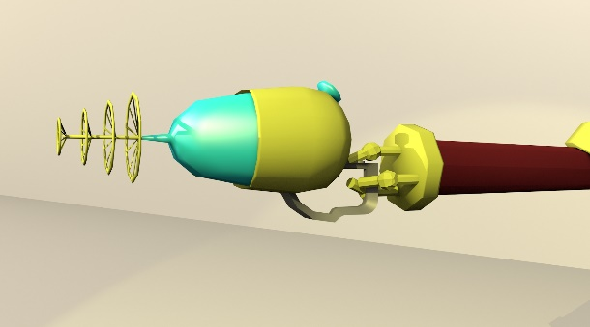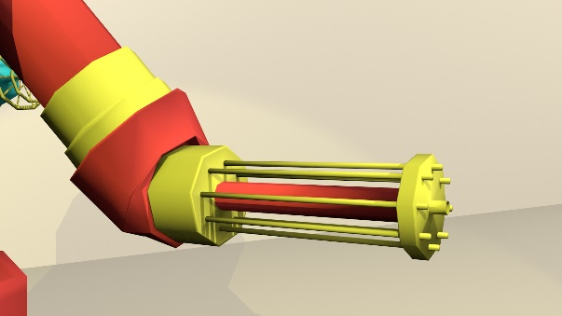An improvement upon previous capsules, RoboPill’s left arm has been replaced by a mini-gun based weapon, which is always readily available. His right arm, however, features 3 opposable fingers which are able to grip secondary weapons. Shown below is a comparison between RoboPill’s Mini Gun arm and his wielding arm.

RoboPill's wielding arm, shown with The Cleanser equipped

RoboPill’s Built-In MiniGun

## Enemies

Enemies within the game will be mainly based on different variations of real-life bacteria that can be found. Each level, a new enemy will be unlocked, which the user will need to logically understand and defeat. Varying AI logic will be applied to each of the enemies, forcing the player to fight strategically whilst at the same time causing as much carnage as possible.

A wave-based spawning system will be utilised in the game, allowing many variations of enemies, adding replay value and unique gameplay which should further the complexity and immersion of the play-through. Although the wave-based spawning system will increase complexity and the need for multi-tasking, having a basic understanding of the game mechanics and enemy AI should allow the player to make it through each level.

## Evolution & Infection Ratio

Throughout the game, the player will accumulate evolution points which can be used for progression. These points can be used to increase the effectiveness of the player, by increasing damage of certain weapons, unlocking new weapons and increasing the player’s defensive values.

Each level will provide a set value of evolution points to ensure the player is able to unlock certain features during their play-through. Furthermore, bonus evolution points will be provided depending on how well the player performed during the previous level.

The “Infection Meter” is a GUI element used to display the ratio of good and bad cells that are present in the subject’s body. When the meter is closer to the left, the subject is in a stable condition, as more healthy cells are present in the body, however, if it travels to the right, this show the subject is unstable, and is near death. If the meter stays here for too long, the subject will die and the player will fail the level.

The status of the Infection Meter will also be relayed to the player using in-game global illumination, allowing the player to stay focused instead of staring at GUI elements.

At regular intervals, the status of the Infection Meter will be recorded, and used as an average throughout the level to calculate the player’s performance, and subsequently, how many bonus evolution points they are awarded.

## Navigation

The player will control RoboPill from an almost orthographic angled camera, whilst retaining full 3D perspective view.

As can be seen in the reference image, RoboPill’s body is section into two parts; Upper & Lower. This allows for more in-depth control of the character in regards to movement and aiming.

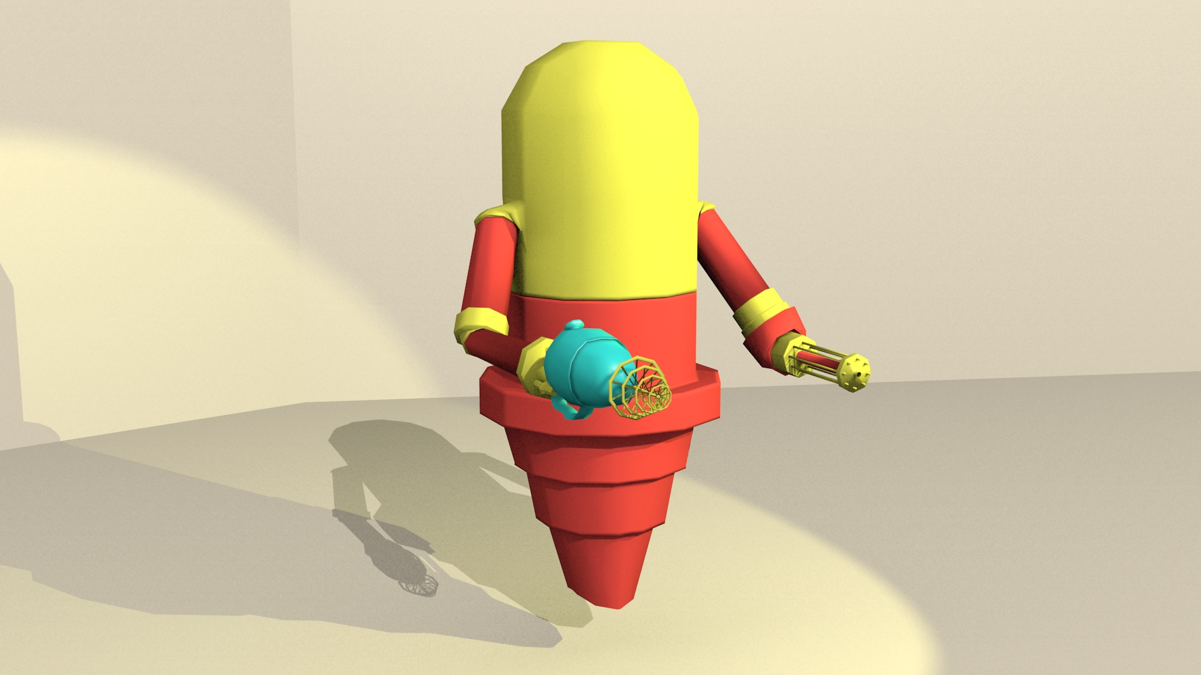

Using WASD or the arrow keys, the player will be able to manipulate RoboPill’s lower-body thruster to move him around the environment using a fixed axis; meaning they will thrust in the same direction regardless of the rotation of RoboPill’s upper-body.

The mouse pointer will be used to rotate the upper-half of RoboPill’s body, giving a full 360 degree range of motion to fire weapons. The upper-half will be rotated depending on the angle between the mouse pointer and the character’s world position.

## UI Design

Aiming for a sleek, minimalistic style, the UI Design will be bare-bones and will only show the player what they need to know. This avoids any clutter on the screen which can be off-putting and distracting, especially in such a high-paced game. Seen below, the user interface will consist of an indicator to show how well the player is doing, their current health and which weapon is equipped. As this is just a sketch, the in-game interface will likely be more aesthetically pleasing.

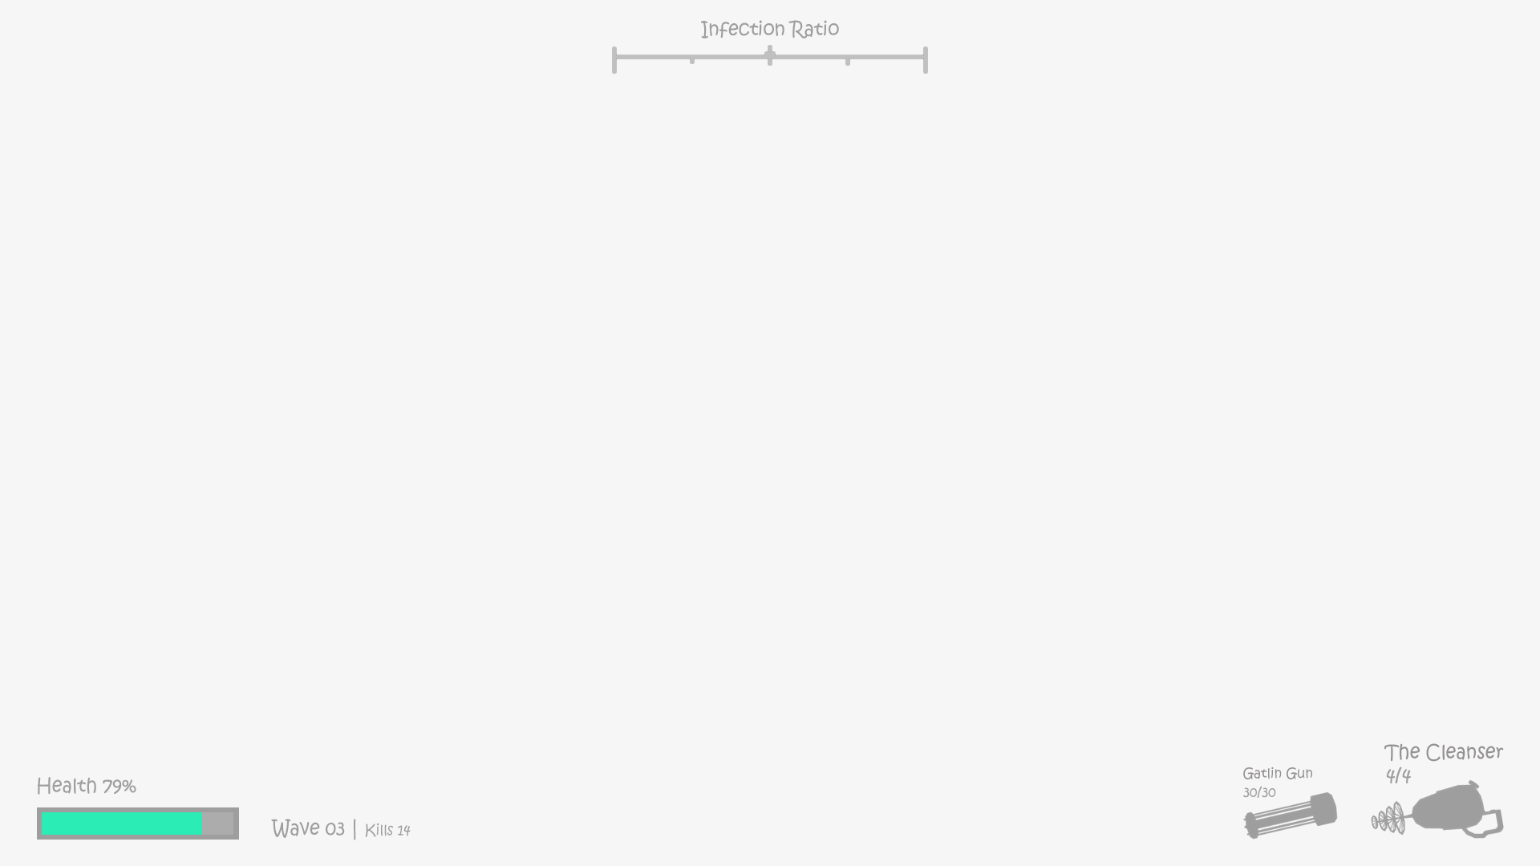

# Requirements

## Functional

## Non-Functional